**PHP Tutorial**

1. Create 2 variables name x & y and assign them the values of 6 and 4 respectively. Then display the sum,multiplication, division and subtraction in the following format.

Sum:10

Difference :2

Product: 24

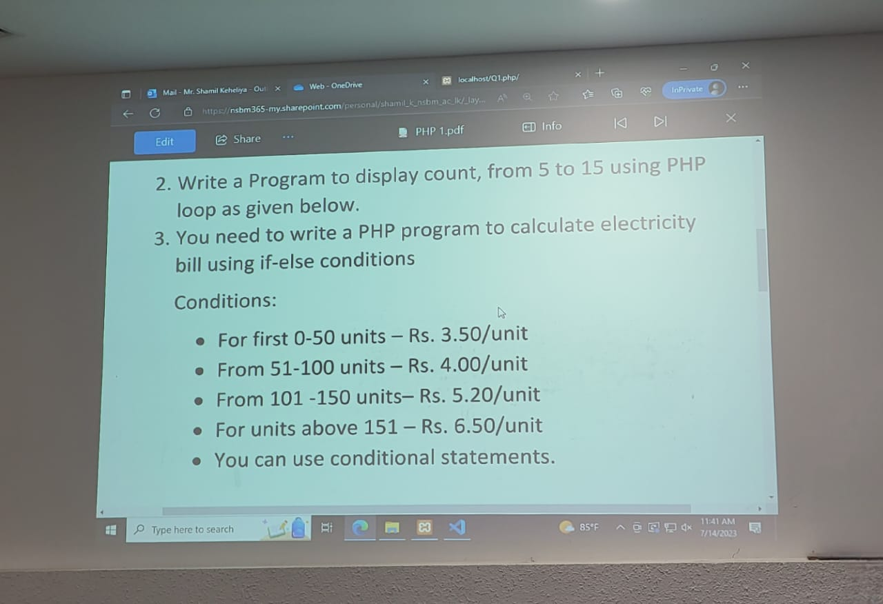Division :1.5